INTRODUCTION
In oil and gas exploration, well logging is an important technique used to evaluate subsurface formations and determine reservoir properties. Logging tools measure various physical properties of rocks and fluids inside a wellbore.
One important logging tool is the Compensated Neutron Log (CNL), which measures hydrogen concentration in the formation and is commonly used to estimate porosity. However, logging tools sometimes experience hardware failures, which can lead to missing measurements.
To solve this problem, a virtual sensor can be developed using machine learning. A virtual sensor predicts the value of a missing measurement using other available logging data.
In this project, machine learning algorithms in Orange were used to predict the Compensated Neutron Log from other well logging measurements.
DATASET DESCRIPTION
The dataset contains measurements from well logging operations. These logs provide information about rock properties and reservoir characteristics.
The variables in the dataset include:
Variable | Description
Photoelectric Factor (PEF) | Measures the interaction between gamma rays and formation materials and helps identify rock type.
Gamma Ray Log (GR) | Measures natural radioactivity of formations and helps distinguish shale from clean formations.
Access Controller | Represents control or resistivity-related measurements from the logging tool.
Density Log | Measures the bulk density of the formation and is used to estimate porosity.
Compensated Neutron Log (CNL) | Measures hydrogen concentration in the formation and indicates porosity.
METHODOLOGY
The analysis was performed using Orange Data Mining, a visual programming tool for machine learning and data mining. Key steps in orange workflow.
.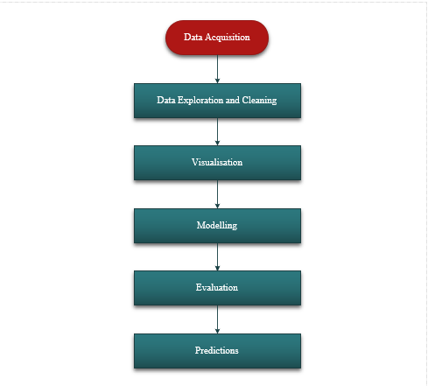

DATA AQUISITION
The dataset used in this project was obtained from Kaggle, an online platform that provides publicly available datasets for data science and machine learning applications. To acquire the data, an account was created and the platform was accessed to search for datasets related to oil well logging and petroleum engineering. A suitable dataset containing key logging parameters such as Gamma Ray, Density, Photoelectric Factor, and Compensated Neutron Log was selected and downloaded in Excel format. The dataset was then imported into Orange Data Mining for further preprocessing and analysis. The data consists of two parts: a training dataset that includes all variables, including the Compensated Neutron Log, and a test dataset in which the Compensated Neutron Log values are missing and must be predicted. This structure makes the dataset appropriate for developing a machine learning model to act as a virtual sensor for estimating missing logging measurements.
DATA EXPLORATION AND CLEANING
Before applying machine learning models in Orange Data Mining, the dataset was carefully pre-processed to ensure accuracy, consistency, and reliability of the results. Data cleaning is an essential step in data analysis, as poor-quality data can significantly affect model performance.
Inputting the Train Data into File Widget
The dataset was loaded into Orange Data Mining using the File widget, which serves as the entry point for importing data into the workflow. The training dataset, provided in Excel (.xlsx) format, was selected and loaded into the File widget to make it available for further analysis. Upon loading, the dataset was automatically displayed, allowing for inspection of the variables and their data types.
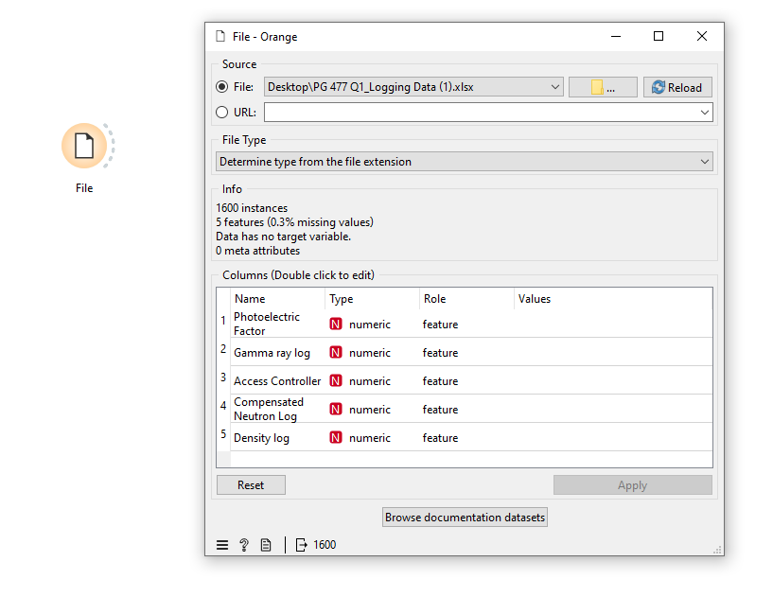
Data visualisation and Inspection
After loading the dataset into the File widget in Orange Data Mining, the data was further explored using the Data Table and Column Statistics widgets to understand its structure and quality.
The Data Table widget was used to visually inspect the dataset in tabular form. This allowed for a detailed examination of individual records and variables, making it easier to identify inconsistencies such as missing values, unusual entries, or incorrect data formats. By scrolling through the data, patterns and anomalies could be quickly observed.
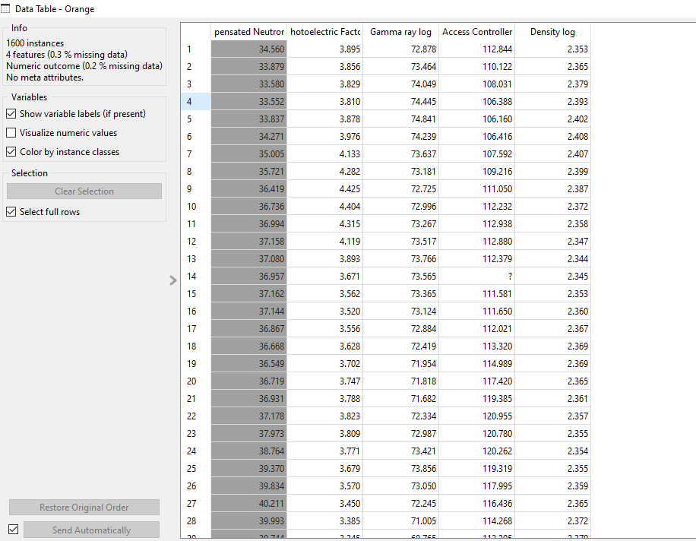

In addition, the Column Statistics widget was used to generate summary statistics for each variable. This included measures such as mean, minimum, maximum, and standard deviation. More importantly, the widget provided information about the presence of missing values in each column, allowing for easy identification of incomplete data.
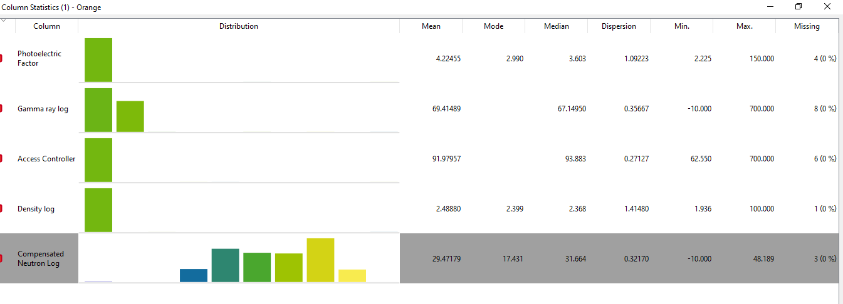

Through this process, variables with missing or inconsistent values were identified and prepared for further cleaning using preprocessing techniques such as imputation and normalization. This initial data inspection step ensured a better understanding of the dataset and helped guide subsequent data cleaning and modelling processes.
Data Cleaning
Data cleaning and preprocessing were carried out in Orange Data Mining using the Preprocess and Impute widgets to improve the quality of the dataset before model training. These steps are essential to ensure that the machine learning algorithms can learn effectively from the data.
The Impute widget was first used to handle missing values in the dataset. Missing data can negatively affect model performance and lead to inaccurate predictions. In this study, numerical missing values were replaced using appropriate imputation methods, such as the mean value of the respective variable. This approach ensures that all records remain usable while maintaining the overall distribution of the data.
.
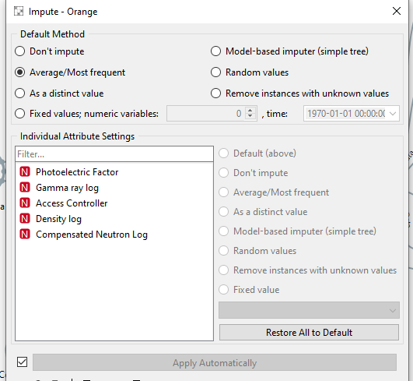

Following imputation, the Preprocess widget was applied to further prepare the data for modelling. One key preprocessing step performed was normalization. Normalization scales the values of all input variables to a common range, typically between 0 and 1. This is particularly important because the logging variables (such as Gamma Ray, Density, and Photoelectric Factor) may have different units and scales
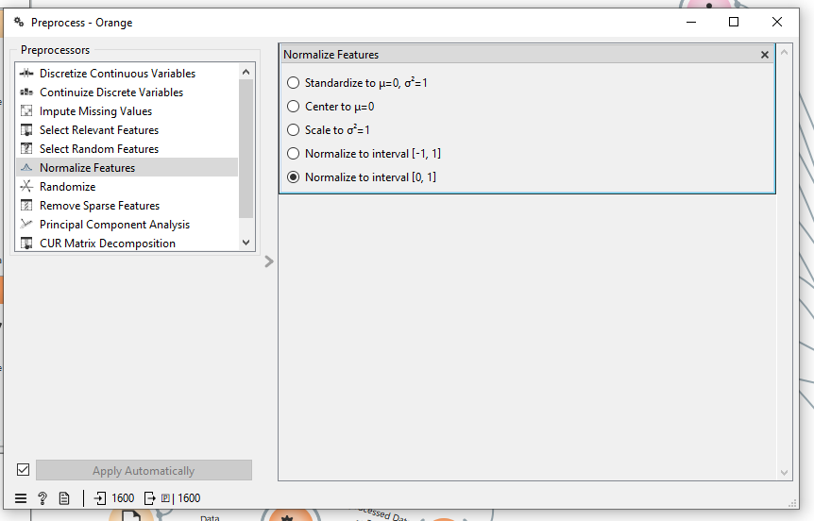

By normalizing the data, no single variable dominates the learning process due to its larger magnitude. This is especially beneficial for algorithms such as k-Nearest Neighbors (kNN) and Support Vector Regression (SVR), which are sensitive to the scale of input features.
Selecting Target Variable
After loading the dataset into Orange Data Mining, the Select Columns widget was used to define the roles of the variables in the analysis. This step is important because it tells the model which variable to predict and which variables to use as inputs.
In this study, the Compensated Neutron Log (CNL) was assigned as the target variable, since the objective is to predict its values using other available logging measurements. The remaining variables, Photoelectric Factor (PEF), Gamma Ray Log (GR), Access Controller, and Density Log were selected as input features. These features are used by the machine learning algorithms to learn patterns and relationships within the data.
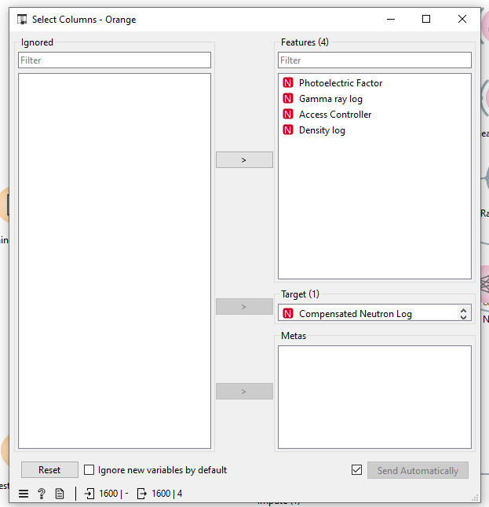

Model Evaluation
The modelling phase of this study involved applying multiple machine learning algorithms to develop a predictive model for estimating the Compensated Neutron Log (CNL). This was carried out in Orange Data Mining after the data had been properly cleaned and pre-processed.
Five different regression algorithms were selected and implemented to ensure a comprehensive evaluation of model performance. These algorithms include Linear Regression, Regression Tree, Random Forest, k-Nearest Neighbours (kNN), and Support Vector Regression (SVR). Each of these models has different strengths in capturing relationships within the data.
The models were connected to the Test & Score widget, where their performance was evaluated using 10-fold cross-validation. In this approach, the dataset was divided into ten subsets, where nine subsets were used for training and one subset for testing. This process was repeated ten times to ensure that each subset was used for validation, providing a reliable estimate of model performance.
Since the target variable, Compensated Neutron Log, is continuous, the modelling task was treated as a regression problem, and stratification was not applied during cross-validation. The models were evaluated using key performance metrics, including Root Mean Square Error (RMSE), Mean Absolute Error (MAE), and Coefficient of Determination (R²).
The purpose of using multiple models was to compare their predictive capabilities and identify the best-performing algorithm. The model with the lowest error values (RMSE and MAE) and the highest R² value was selected as the most suitable model for predicting the missing neutron log values.
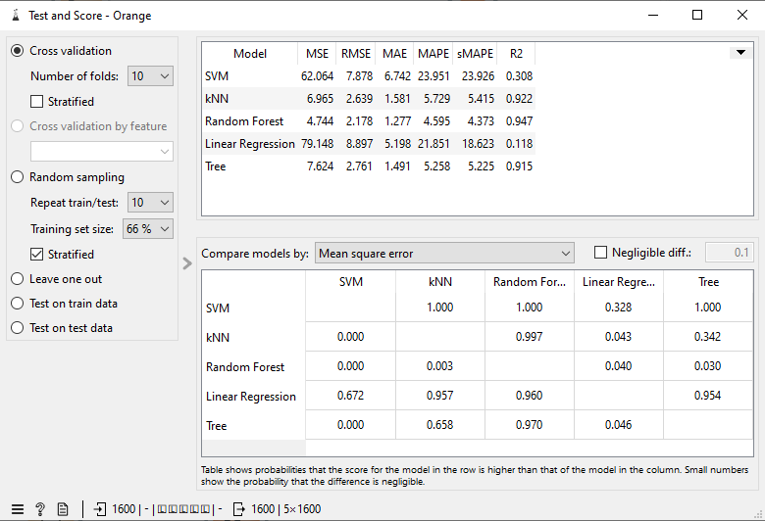

Test Dataset and Predictions
After training and evaluating the machine learning models in Orange Data Mining, the test dataset was used to generate predictions for the missing values of the Compensated Neutron Log (CNL).
The test dataset contains the same input variables as the training dataset, Photoelectric Factor (PEF), Gamma Ray Log (GR), Access Controller, and Density Log, but does not include the Compensated Neutron Log. This simulates a real-world scenario where the neutron logging tool has failed, and its measurements are unavailable.
To perform the prediction, the test dataset was loaded into the File widget and connected to the Predictions widget. The best performing model, as identified from the Test and Score evaluation, was then connected to the Predictions widget. The model used the input variables from the test dataset to estimate the missing Compensated Neutron Log values.
The output from the Predictions widget provided a new column containing the predicted CNL values for each record in the test dataset. These predicted values represent the output of the virtual sensor and can be used for further reservoir analysis and decision-making.
This step demonstrates the practical application of machine learning in oil and gas operations, where predictive models can be used to replace missing measurements and ensure continuity in data analysis.
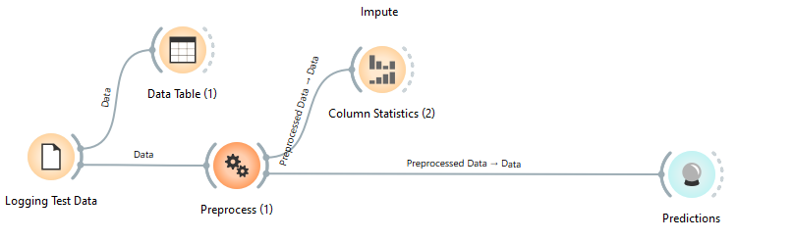

Overall Workflow
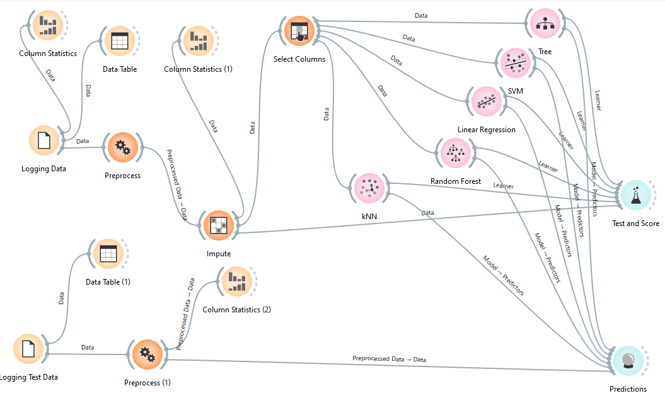
Results and discussion
Root Mean Square Error (RMSE), Mean Absolute Error (MAE), and Coefficient of Determination (R²). RMSE and MAE measure the prediction error, where lower values indicate better performance, while R² measures how well the model explains the variability of the target variable, with values closer to 1 indicating better performance.
The results showed clear differences in the performance of the five models. Random Forest achieved the best overall performance, with the lowest RMSE (2.178) and MAE (1.277), and the highest R² value (0.948). This indicates that Random Forest provided the most accurate predictions and was able to capture the relationship between the input variables and the target variable effectively.

The k-Nearest Neighbours (KNN) and Regression Tree models also performed reasonably well, with relatively low error values and high R² scores of 0.922 and 0.915 respectively. However, their performance was slightly lower than that of Random Forest.
On the other hand, Support Vector Machine (SVM) and Linear Regression showed poor performance, with significantly higher RMSE values (62.06 and 79.15 respectively) and low R² values (0.308 and 0.118). This suggests that these models were not able to effectively capture the underlying patterns in the dataset.
Overall, the evaluation results indicate that ensemble methods such as Random Forest are more suitable for this type of regression problem, as they can handle complex relationships within well logging data more effectively than simpler models.
The predictions for all the models
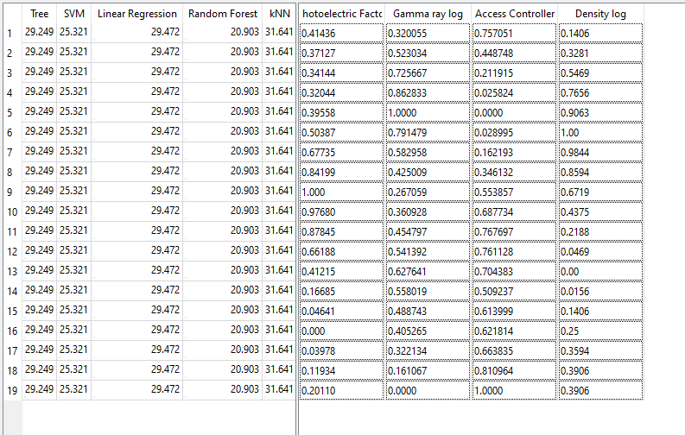

Conclusion
In conclusion, this project highlights the importance of data preprocessing, model selection, and evaluation in building accurate predictive models. The use of machine learning as a virtual sensor provides a practical solution for handling missing logging data and can support better decision-making in reservoir analysis.

